***What is Ethereum?***

Ethereum tries to create an application that runs on decentralized network. Means that every one of us will execute the program, not as Facebook where everything relies on 1 single server.

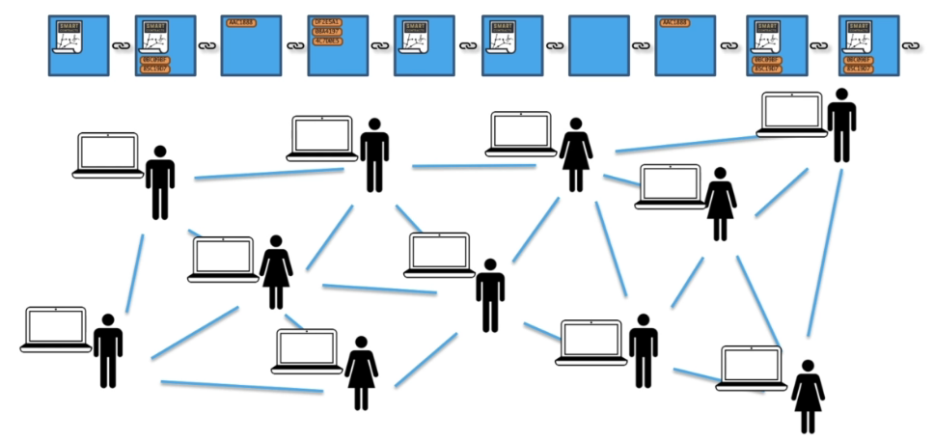

***What is Smart Contract?***

Difference between Bitcoin Script and Solidity is that Solidity is Turing-Complete while Bitcoin Script is not. The reason is because Solidity has loops.

